TRANSPARENCY in the WORLD and TURKEY
Initiative for Freedom of Expression
Transparency Association
Istanbul Bilgi University Human Rights Law Research Center
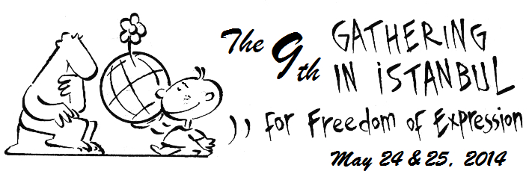
Istanbul Bilgi University (santralistanbul Campus)

24 May 2014 Saturday

09:30 OPENING SPEECHES (Names in alphabetical order)
Dr. Karin Deutsch Karlekar (Freedom House), Andrew Gardner (a.i.), Nathalie Losekoot (Article 19), Eugene Schoulgin (International PEN), Emma Sinclair Webb (HRW), Prof. Turgut Tarhanlı (Istanbul Bilgi University)
Video messages: Johann Bihr (RSF), Annie Game (IFEX), Dunja Mijatovic (OSCE), Joel Simon (CPJ), J. C. Weliamuna (Transparency International)
10:30 TESTIMONIES-1: Victims/Witnesses from Turkey will testify
11:15 .......... COFFEE BREAK ...................
11:30 PANEL-1: TRANSPARENCY AND FREDOM OF EXPRESSION
Prof. Dr. Yaman Akdeniz (Moderator, Istanbul Bilgi University)
Sevi Fırat (Transparency Association- Turkey)
Ali Rıza Keleş (Alternative Communication Association)
12:30 PANEL-2: TRANSPARENCY IN PUBLIC WORK
Hıfzı Deveci (Public Administration Consultant)
Gönenç Gürkaynak (Lawyer)
Fikret Toksöz (Moderator, HYD/Helsinki Citizens Assembly Governance Consultant)
13:30 *********LUNCH BREAK *******
14:45 TESTIMONIES-2: Victims/Witnesses from Turkey will testify
15:30 PANEL-3: ROLE of the MASS MEDIA and SOCIAL MEDIA
Ercan İpekçi (Journalist)
Turgay Olcayto (Journalists Association of Turkey)
Erol Önderoğlu (Moderatör, Bianet, RSF)
Deniz Zeyrek (Ankara representative of Daily Hurriyet)
16:30 .......... COFFEE BREAK ...................
16:45 PANEL-4: SOMA CATASTHOPHE and TRANSPARENCY IN TURKEY
Ass. Prof. Dr. Aziz Çelik (Kocaeli University)
Murat Dinçer (Lawyer, Helsinki Citizens Assembly and CHD Contemporary Lawyers)
Prof. Dr. Turgut Tarhanlı (Moderatör,İstanbul Bilgi University)
*****************************************************************************
25 May 2014 Sunday

14:00 HOW TRANSPARENT DOES TURKEY LOOK?- 2
William Nygaard (Norwegian PEN- Chairman; Publisher)
Nathalie Losekoot (Article 19, Senior Program Officer-Europe)
Eugene Schoulgin (Author, International PEN, Vice President)
15:00 FREEDOM OF THE WORLD MAP (Freedom House Report)
Dr. Karin Deutsch Karlekar (Freedom House, Managing Editor)
Nevşin Mengü (Moderator, CNN TURK)
16:00 ................. COFFEE BREAK ................
16:15 TELECONFERENCE
Prof. Noam Chomsky (MIT- Massachuttes Institute of Technology- USA)
Şanar Yurdatapan (Moderator, Initiative for Freedom of Expression)
17:15 Opening of The MUSEUM OF CRIMES of THOUGHT
By Prof. Noam Chomsky (on SKYPE)

